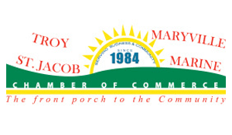

**FOR IMMEDIATE RELEASE**

647 E. US Highway 40

(618) 667-8769

Troymaryvillecoc.com

**Troy Family Summer of Fun Movie Night – *Jumanji***

TROY, IL. – The Troy/Maryville/St. Jacob/Marine Chamber of Commerce will be hosting a movie night, sponsored by First Mid Bank & Trust, Renewal by Andersen, Maryville Carstar, Mathis Marifian & Richter Ltd, and Gateway Regional Medical Center at Tri-Township Park on August 24th. This movie is a reschedule. Entertainment will begin at 6:00 p.m. and *Jumanji*, shown by Copious Technologies, will begin at 8:15 p.m.

Entertainment includes a petting zoo, music by Big Papa G, face painting by Stacey’s Faces, bounce houses (provided by Gateway Church and Gateway Bounce), Ardy the Clown, Caricatures by Jim Heil and more. Pathway Church will be providing FREE food and drinks. The movie will be shown by Copious Technologies.

Be sure to bring your lawn chairs, blankets and leave your wallets at home – everything is FREE! For more information on how to join in on the fun, visit [www.troymaryvillecoc.com](http://www.troymaryvillecoc.com/) or call the Chamber office at 618-667-8769. Events are possible through the City of Troy tourism funding and the Tri-Township Park.

###